DEPARTMENT OF BOTANY
SNGAP SYIEM COLLEGE
MAWKYRWAT
FIELDTRIP REPORT

ORGANISED BY: The Department of Botany, Sngap Syiem College, Mawkyrwat organized the field trip on 21st October, 2023 to Nongnah village, a place which falls under South West Khasi Hills District of Meghalaya. Teachers concerned Smt P. Lyngkhoi and Smt W. Lyngkhoi and all the third semester and first semester FYUG students participated in this field trip.
PURPOSE: The chief purpose of the field trip is to give students first hand experiences that cannot be had in the classroom. It provides opportunities for learning through the use of many techniques other than in the classroom.
ABOUT THE TRIP: We reached our destination, i.e. Nongnah village at 9: 30 a.m. Our first spot at Nongnah village is a place called Phot Um sum where a lot of pitcher plants are found. This place is a private property which gets financial aid from the government. This is the place where pitcher plants are specially conserved. We then headed to Iawpaw hills, where we can see the whole village of Nongnah as well as other places like Bangladesh. From there, we went to Mawtynhiang cave and on the way we see broomstick cultivation on a large scale. The cave is dark and damp and has formations like stalactites and stalagmites. These are made over thousands of years by dripping of water and leaving mineral deposits. Some creatures like bats and spiders are found in the cave. Lastly, we went to Phot Sum Chrieh, a dangerous natural swimming pool. This pool is in the middle of a steep slope. This pool is surrounded by mountains and slopes with a pointy edge. After coming back from Phot Sum Chrieh,we headed back to our college at 4:00 p.m. and then to our homes.
OUTCOME: This trip gives a general account of the vegetation of Nongnah village. Nepenthes khasiana or pitcher plants are specially conserved in this village. Besides Nepenthes, other species like Melastoma sp., Arundina graminifolia, Anthogonium gracile, Spathoglottis sp., Pogostemon sp., Crotalaria meghalayensis ,Smilax ferox, Thysanolaena maxima , Daphne papyracea, Impatiens sp. , Emilia sonchifolia, Pogostemon sp., Impatiens sp. Crotalaria meghalayensis, big ferns, many bamboo species,etc. were also observed.

Fieldtrip of BSc 3rd and 1st Semesters to Nongnah on 21st October 2023
BEFORE THE TRIP
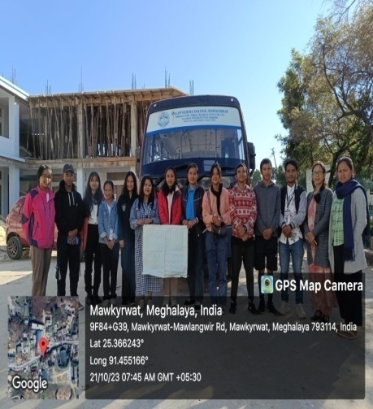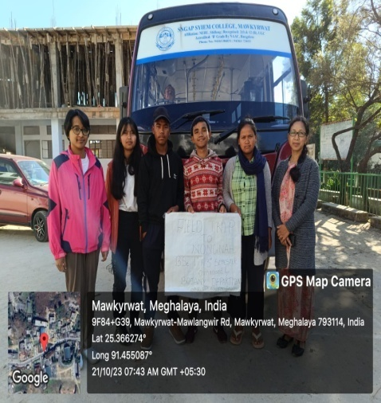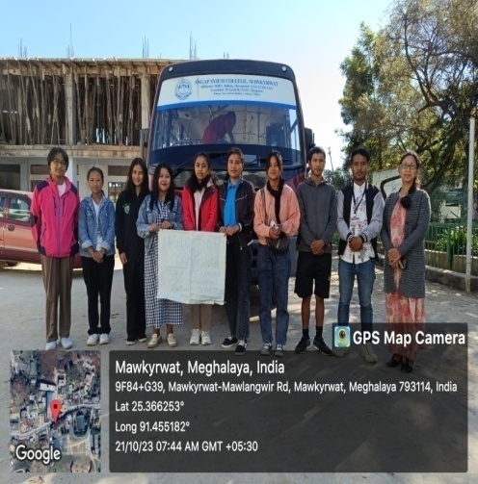

AT THE PITCHER PLANT GARDEN, PHOT UMSUM
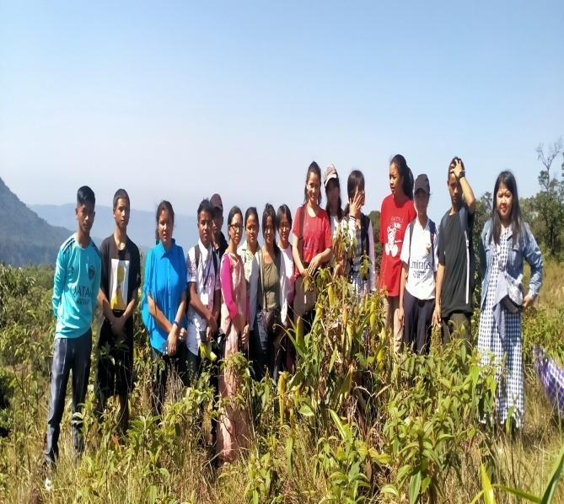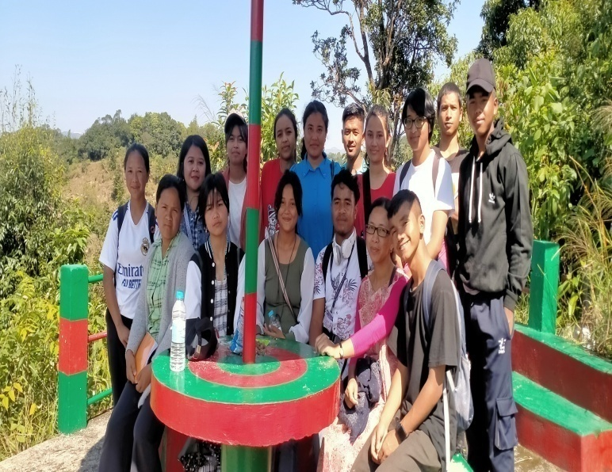
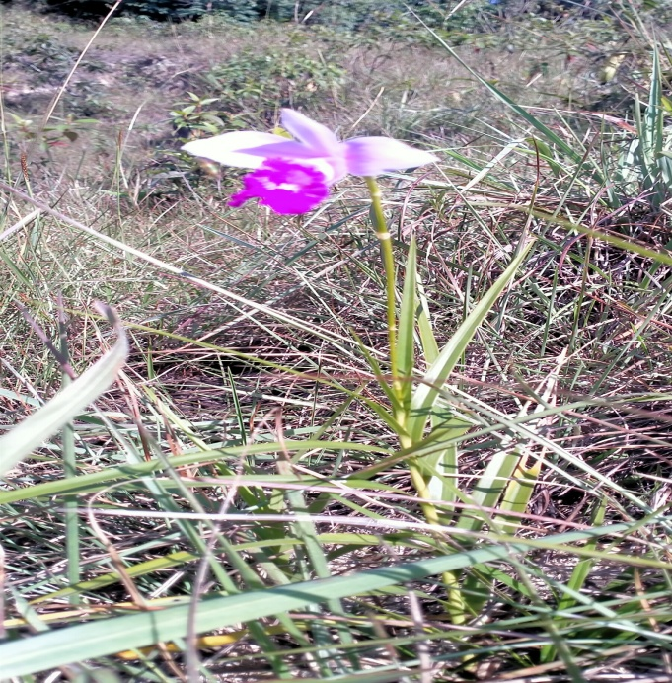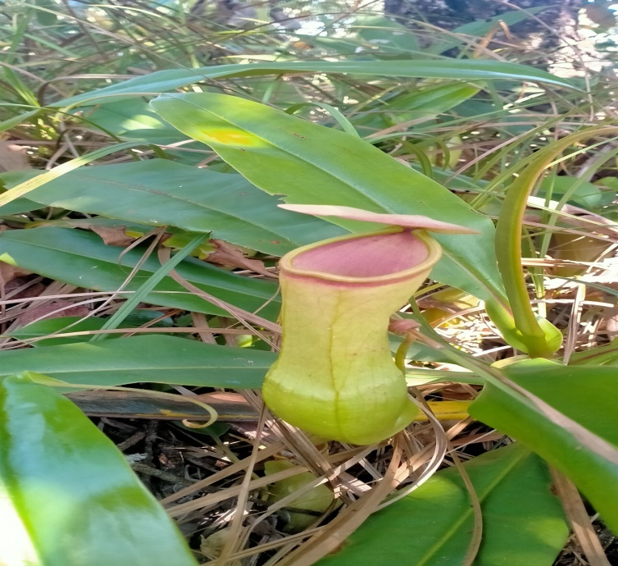

AT LUM IAWPAW
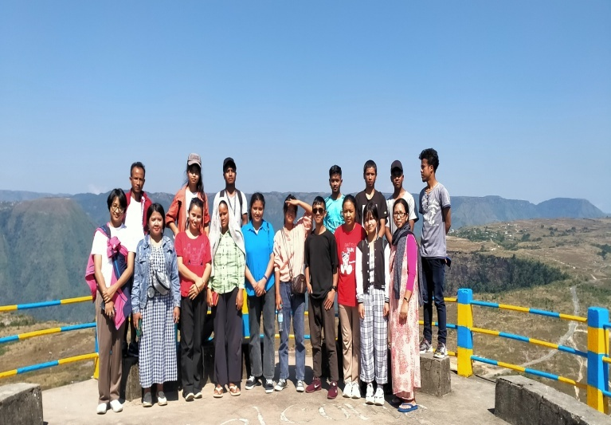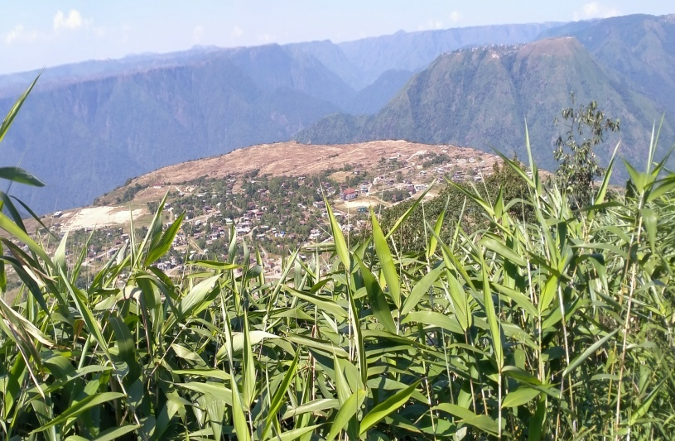
AT
AT KREM MAWTYNHIANG
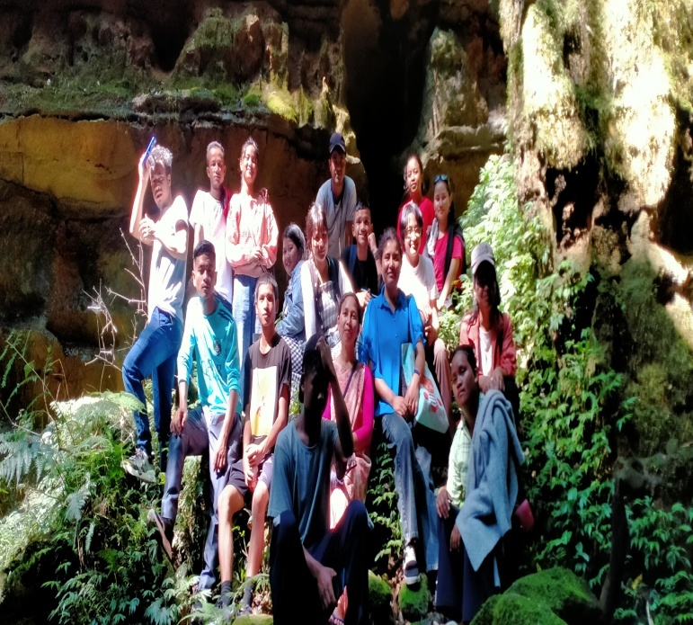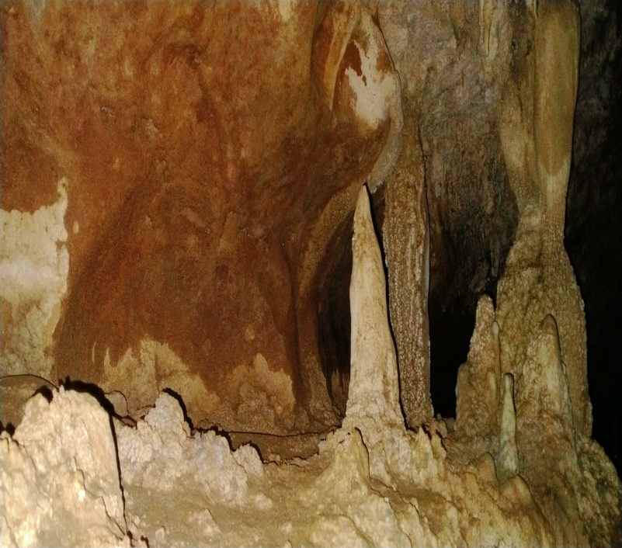
AT PHOTSUM SHRIEH
